Questions on House Purchase
Information on House, Owner & Broker
House Address (with area name, pin code)
House facing direction
(fencing gate and main gate)
Landmark near Ukkadam, to locate this house
Total Land Area (In Sqft)
Total buildup Area (In Sqft)
Pending work / Notes ?
Any local problems for this house (mafia – gunda – dada) – ask the locality. (No offense)
Owner Still alive ? (No offense)
House Sold by Owner or his children / grand children's ? - For signature reasons
Owner Name
Owner Address & Contact Number | .
Purpose of sale
Broker Name
Broker Address & Contact Number
Builder Info
Building Completed Date

Land & House Information
Pathram & Patta photo copy (xerox) – Please collect a photo copy of these documents | Yes / No
Legal Opinion  1) Verify orginal Pathram & Patta  2) Any Legal Case on Land or Building  3) Villangam Certificate / Document  4) Sale history of the property, and the current owner info from the government department or lawyers legal opinion | Yes / No
Building License approval , Layout approval, Sub division approval - documents | Collect Document photo copy and document numbers – check weather the building has be built accordingly
Property tax paid till
House tax paid till
Government Municipal Approved Area ? (for water, drainage, electricity, telephone)
Rain water harvesting Required / Available
House Fencing Required / Available ?
Vaastu Shastra (Feng Shui) Verified ? | Yes / No (to self verify – please check the picture)
Number of rooms (excluding 1 hall and 1 kitchen and toilets)
Number of toilets (Indian, western)
Number of floors
Number of stairs ?
House is built using pillars or with out pillars (kallukattu – simple stone concrete)
How many floors can be raised further
What is the expected life of the house | Number of years
What modification you foresee to be done on this house (painting, building fence, or plaster - finish work)
Comment how the outside of the house looks (including roads, cleanliness, are there empty areas near this house – info on that ?)
Conditions of Doors / Windows, Floor (marble - mosaic ?), roof – ceiling, cracks
Is the terrace ready with red stone flooring for rain prevention ?
Any cracks on walls or leaks foreseen ?
How much empty space on the 4 sides of house ?
Any litigations with neighbors ?
Parking space for (2 wheeler, car – inside / outside / open space )

Sale & Payment Information

Land Value per sqft on the same area | 2004  2005  2006  2007
Worth of land alone (approximately)
Worth of building alone (approximately)
Worth of the resident house with land
Housing Loan Taken ?
Any Unpaid Loan ? (Status)
Broker fees % or a fixed amount
Registration charges
Lawyer and legal fees, other charges
Total value of the transaction
Payment terms | Cash / Cheque / DD
Payment Duration | 1 months to 6 months or 1 shot payment
Witness ready on both sides ?

Info on House Facilities
Municipal Water Connection Available ?
Other Sources of water (bore well, well)
Number of water tanks (sump, overhead tank)
Do they have motor for pumping water to tanks ?
Water connection (board meter) number
Water connection active ?
Water bill paid till ?
Water problems so far ?
EB Connection (board meter) Number
EB Connection active
EB bill paid till ?
Electrical Equipments & House Fittings
Number of tube lights, bulb, fan connections ?
Number of tube lights, bulb, fan provided ?
Number of wash basin / kitchen sinks
Comments on Drainage systems (inside house)
Notes on Electrical Equipments & House Fittings
Time required to do “change of name / ownership” for EB, Water etc.,

Below is the Vaastu Shastra picture, please check the house with the same.
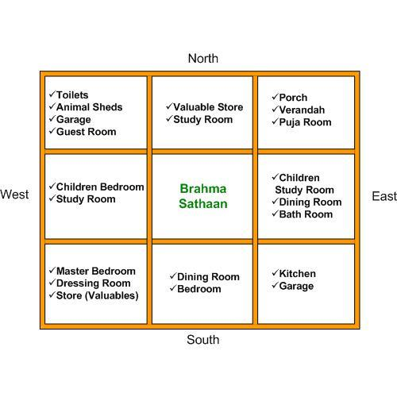
Photocopy means xerox/carbon copy (dark print, should be neat & readable)
OTHER GENERAL NOTES
FLAT NOTES

- CHECK WHETHER THE DETAILS OF APPROVED PLAN HAS BEEN DISPLAYED AT THE SITE.
- CHECK WHETHER THE FLAT HAS BEEN CONSTRUCTED AS PER THE APPROVED PLAN.
- CHECK WHETHER THE PROMOTER/POWER OF ATTORNEY HAS A RIGHT TO TRANSFER THE UNDIVIDED SHARES OF LAND.
- VERIFY WHETHER ENTIRE UNDIVIDED SHARES OF LAND HAS BEEN TRANSFERRED BY THE
- LAND OWNER/PROMOTER/POWER OF ATTORNEY TO YOU.
- LAND OWNER/PROMOTER/POWER OF ATTORNEY HAS NO RIGHT OVER THE OPEN SPACES AND IN THE TERRACE AFTER ENTIRE UNDIVIDED SHARES OF LAND HAS BEEN TRANSFERRED.
- CHECK WHETHER THE COMPLETION CERTIFICATE ISSUED BY THE LOCAL BODY HAS BEEN OBTAINED AFTER THE COMPLETION OF THE BUILDING.
- IF YOU HAVE ANY FURTHER CLARIFICATIONS REGARDING PURCHASE OF PLOT/FLAT,
- KINDLY CONTACT THE COUNSELLING COUNTER AT LOCAL BODY.

LAND NOTES

- CHECK WHETHER THE SELLER HAS A RIGHT OVER THE PROPERTY.
- CHECK WHETHER THE LAYOUT HAS BEEN APPROVED BY THE LOCAL BODY. (COPY OF APPROVED LAYOUT CAN BE OBTAINED FROM THE LOCAL BODY FOR NOMINAL FEE)
- CHECK WHETHER THE ROADS AND PARK AREA HAS BEEN HANDED OVER TO THE LOCAL BODY THROUGH A GIFT DEED
- CHECK WHETHER THE ABUTTING ROAD OF THE PLOT HAS BEEN MAINTAINED BY THE LOCAL BODY OR HAS BEEN HANDED OVER TO THE LOCAL BODY.
- VERIFY WHETHER THE PLAN HAS BEEN PREPARED ACCORDING TO THE DEVELOPMENT CONTROL RULES.
- TO CHECK WHETHER ALL THE DOCUMENTS/CERTIFICATES HAS BEEN ENCLOSED BEFORE SUBMITTING THE PLAN FOR APPROVAL TO LOCAL BODY.
- TO OBTAIN PLANNING PERMISSION FROM LOCAL BODY AND BUILDING APPROVAL FROM THE CONCERNED LOCAL BODY.
- IF NOT ACTION WILL BE TAKEN AGAINST THE UNAUTHORISED AND DEVIATED CONSTRUCTIONS.
- KINDLY AVOID UNAUTHORISED/DEVIATED CONSTRUCTION AND STAY FREE FROM THE ENFORCEMENT ACTION OF LOCAL BODY.

LOCAL BODY MEANING - ANY ONE OF THE BELOW:

- Municipal Administration and Water Supply,
- TAHSILDAR, Panchayat, A village council in India
- Department of Stamps & Registration,
- TAMIL NADU REGISTRATION DEPARTMENT
- Housing and Urban Development
- Rural Development

