How Struts Work?
Requirements:
- Tomcat Latest Stable version installed and working.
- Idea on jsp:useBean and jsp:setProperty
- Unzip my example SimpleMVC.zip to tomcat_home\webapps\

Note: When an html form is posted we can capture all the data using a java bean with the help of jsp:useBean and jsp:setProperty, this knowledge will help you to understand ActionForm.

Hardcore Struts

JSP Page (View) will call the controller on request or submit.

The steps involved in calling a controller are as follows.

If you see web.xml, which does the mapping you will understand that any request such as post, get, put* from a client/view will invoke a servlet called action.

* For knowing other http methods other than post, get, put please visit http://www.w3.org/Protocols/rfc2616/rfc2616-sec9.html

<!-- Standard Action Servlet Mapping -->
<servlet-mapping>
<servlet-name>action</servlet-name>
<url-pattern>*.do</url-pattern>
</servlet-mapping>

action will be executed for any request which ends with “.do”

What is action?

Here action is a name

Below action is described and mapped to a servlet called org.apache.struts.action.ActionServlet (Main Struts Controller)

<servlet>
<servlet-name>action</servlet-name>
<servlet-class>org.apache.struts.action.ActionServlet</servlet-class>
<init-param>
<param-name>application</param-name>
<param-value>ApplicationResources</param-value>
</init-param>
<init-param>
<param-name>config</param-name>
<param-value>/WEB-INF/struts-config.xml</param-value>
</init-param>
<init-param>
<param-name>debug</param-name>
<param-value>2</param-value>
</init-param>
<init-param>
<param-name>detail</param-name>
<param-value>2</param-value>
</init-param>
<init-param>
<param-name>validate</param-name>
<param-value>true</param-value>
</init-param>
<load-on-startup>2</load-on-startup>
</servlet>

Basically we can understand that any request that ends with “.do” will activate org.apache.struts.action.ActionServlet (named as action)

We are allowed to change the name from action¹ to MyOwnName² too, as below.

¹ - <servlet-name>action</servlet-name>
² - <servlet-name>MyOwnName</servlet-name>

I am not going to discuss about application resources (resource/application. properties).

Controller is totally responsible to send the data from view to model and bring back the data from model to view.

ActionForm and Action constitutes model. ActionForm contains data and Action can manipulate ActionForm.

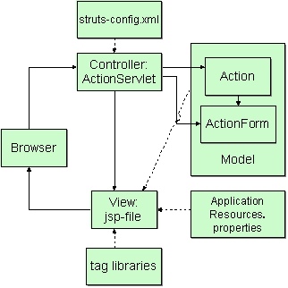

Please check my example.

ActionForm is something like your bean with has set/get properties, which you use for capturing FORM information.

If you need struts doc (API), mail me. I am pleased to answer all your questions. Please feel free to ask questions related to MVC- Struts.

Regards,
Muthu Veerappan
muthu@periyakaruppan.com
BuddhiBase Team
http://groups.yahoo.com/group/BuddhiBase

Quotes

Knowledge is power and enthusiasm pulls the switch.

There is far greater peril (state of danger involving risk) in buying knowledge than in buying meat and drink

Wonder rather than doubt is the root of knowledge.

Knowledge fills a large brain; it merely inflates a small one.

Knowledge fills a large brain; it merely inflates a small one.

True knowledge exists in knowing that you know nothing.
And in knowing that you know nothing, that makes you the smartest of all.

It is the province of knowledge to speak and it is the privilege of wisdom to listen.

